Events and Announcements

Happy birthday! Many happy returns and best wishes to Noel Tanangonan. Are there any other birthdays this week? If so, let us know so we can celebrate your special day.

Funeral services for Caridad Ines – a deeply beloved member of our congregation – will be held here at Culmore Church on Tuesday, September 24th at 11:30 AM. Visitation will take place beginning at 9:30. Internment will be at Arlington National Cemetery at a later date. A reception will follow the service.

Charge Conference will be held on Saturday, October 5th between 10:00 AM – 12:30 PM. This year’s host church will be Galloway UMC located at 306 Annandale Rd, Falls Church, VA 22042. All members of Culmore’s leadership committee are strongly encouraged to attend.

Bible Study is Wednesday, September 25 at 10:00, as we continue our study of the book of James. Come for coffee and discussion.

Culmore United Methodist Church

September 22, 2019
3400 Charles Street
Falls Church, VA 22041
Tel. 703-820-5131

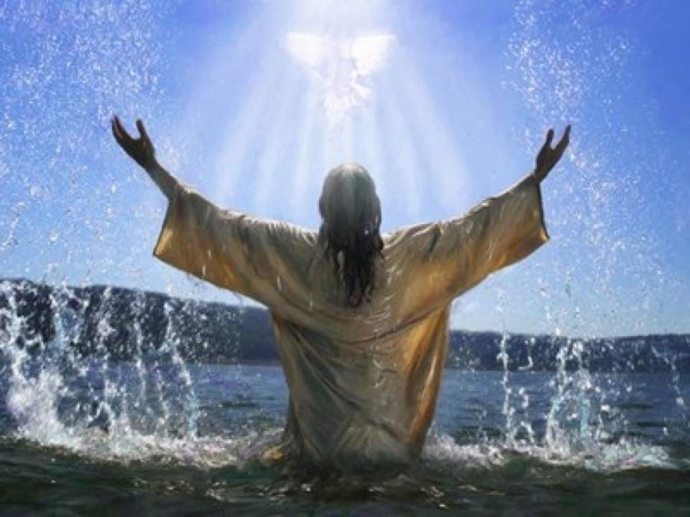

“…And surely, I am with you always,
to the very end of the age.”
Matthew 28:20
Culmore United Methodist Church
September 22 , 2019

Pastors: Rev. Nelson Neil, Rev. Beth Neil
Music: Dr. Wonhee Kang, All Nations Choir

Reflection: I have been crucified with Christ and I no longer live, but Christ lives in me. The life I live in the body, I live by faith in the Son of God, who loved me and gave himself for me. –Galatians 2:20

Prelude The Risen Christ W&S 3179

Welcome and Announcements

Passing of the Peace

Scripture: Matthew 7: 24-27

Hymn If You Could See Me Now (see insert)

Opening Prayer:
Eternal God,
Reveal your presence to us everywhere. Help us become aware of your presence every moment of each day. Let your presence fill our voids; the nonanswers,
the empty glances, and the lonely times,
that we may truly know that we are never alone. Amen.

Responsive Reading: (UMH # 883)
We are not alone; we live in God’s world.
We believe in God who created and
is creating, who has come in Jesus,
the Word made flesh.

To reconcile and make new, who works in us and others by the Holy Spirit.
We are called to celebrate God’s
presence, to love and serve others,
to seek justice and resist evil.

To proclaim Jesus, crucified and risen, our judge and our hope.
In life, in death, in life beyond death,
God is with us.
We are not alone.
Thanks be to God. Amen

Hymn In the Bulb UMH 707
Community Prayer
Anthem Nearer, My God, to Thee
Doxology UMH 95

Scripture: Revelations 21:1-7
Sermon: We Are Never Alone
Hymn We’ll Understand It Better UMH 525
Benediction

