Events and Announcements

Happy birthday! Are there any birthdays this week? If so, let us know so we can wish you many happy returns.

A Culmore Leadership Team meeting is over-due. Financial results up to June 30th are ready for presentation along with an estimate to year-end. Additionally, there are several administrative issues which require discussion. Sunday, August 11th (following worship) is proposed as a date for the next meeting. Please mark your calendar.

Wedding Announcement: We are pleased to announce that Wilfredo Morales and Sarah Fong will be married on Saturday, August 10 in Alexandria. Culmore congregation extends our best wishes to the couple!

Next Sunday, July 28th there will be a Culmore United Methodist Church congregational lunch at Sardi’s Peruvian Restaurant (in the strip mall across the street.) Please be there. Also for those who typically bring casseroles, sandwiches and other delightful goodies, you can take a break from cooking and baking next Sunday thanks to the generosity of our hosts Mr. Wayne and Mrs. Angela Valis.

MAP is up and running at Culmore. This FREE health clinic is open on Thursdays between 7:00AM – 2:00PM. Since there are a limited number of appointments available each Thursday, come at 6:00 AM to ensure being seen. The only requirement is that you come.

Bible Study is Wednesday, July 17 at 10:00, as we continue our study of Hebrews. Come for coffee and discussion.

Culmore United Methodist Church

July 14, 2019

3400 Charles Street, Falls Church, VA 22041
Tel. 703-820-5131

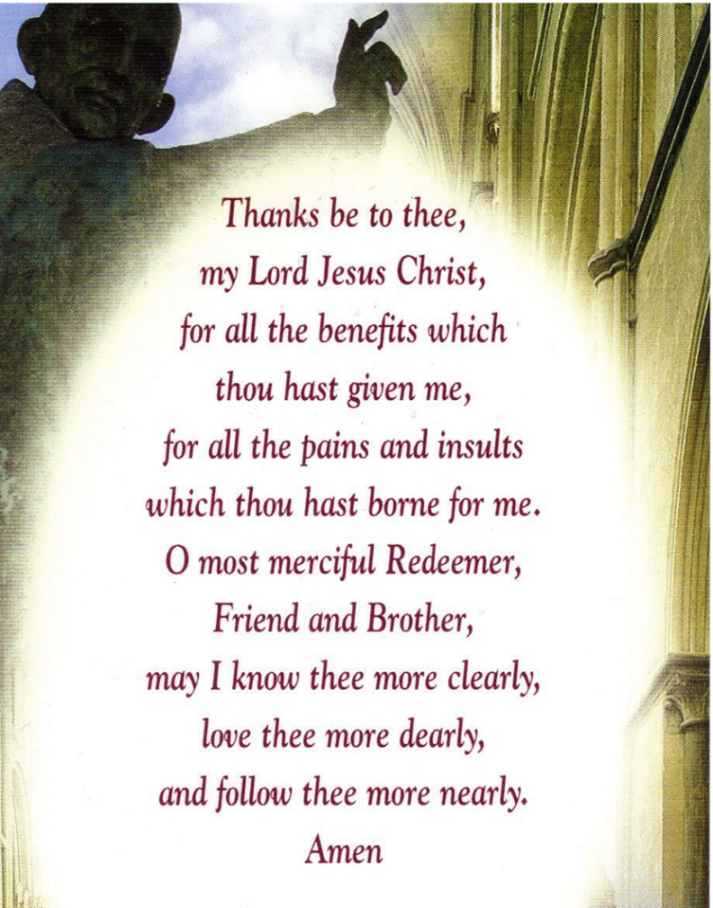
Prayer of Saint Richard of Chichester
(1197 – 1253)

Culmore United Methodist Church
July 21, 2019

Pastors: Rev. Nelson Neil, Rev. Beth Neil
Music: Dr. Wonhee Kang, All Nations Choir

Reflections: Prayer does not change God but it changes the person who prays –Soren Kierkegaard (1813 – 1855)

When you can’t put your prayer into words, God listens to your heart –Anonymous

Prelude Sanctuary TFWS 2164

Welcome and Announcements

Passing of the Peace

Lectio Divina Meditation: Matthew 16: 13-18

Hymn Day by Day by Day (see insert)

Responsive Reading: Psalm 5 (adapted)
Listen to my words, O Lord, give heed to my sighing.

Listen to my cry for help, my King
and my God, for to You do I pray.

In the morning You hear my voice, O Lord. In the morning I prepare a prayer for You and wait for You to speak to my heart.

You are not a God who takes pleasure
in wickedness. With you, the wicked
cannot dwell.
Boasters cannot stand in your presence.

But I will enter Your house through
the abundance of Your steadfast love
and mercy.

In reverence will I bow down before You.

Lead me, O Lord, in Your righteousness.
Make straight Your way before me.

Let all those who take refuge and put their trust in You rejoice. Let them ever sing for joy. Amen

Hymn: Sweet Hour of Prayer UMH 496

Scripture: Matt. 6: 5-8, Luke 18:9-13

Sermon: Get Better Acquainted with God

Anthem I’ve Got Peace Like a River

Doxology UMH 95

Community Prayer

Closing Hymn: It’s Me, O Lord UMH 352

Benediction

