Events and Announcements

Happy birthday! Are there any birthdays this week? If so, let us know so we can wish you many happy returns.

MAP is up and running at Culmore. This FREE health clinic is open on Thursdays between 7:00AM – 2:00PM. Since there are a limited number of appointments available each Thursday, come at 6:00 AM to ensure you can be seen. The only requirement is that you come.

Bible Study is Wednesday, June 26 at 10:00.
Come for coffee and discussion.

Culmore United Methodist Church

June 23, 2019
3400 Charles Street
Falls Church, VA 22041
Tel. 703-820-5131

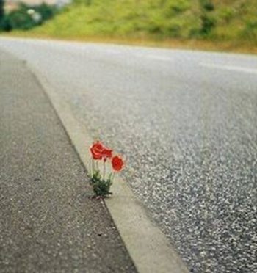

Faith works miracles.
Ang pananampalataya ay
gumagawa ng mga himala.

La fe hace milagros.

Culmore United Methodist Church
June 23, 2019

Pastors: Rev. Nelson Neil, Rev. Beth Neil
Music: Dr. Wonhee Kang, All Nations Choir

We invite all to rest in the peace of Christ,
to explore the word of God,
and to shine God’s light in the world.

Personal Reflection: Draw near to God, and he will draw near to you.--James 4: 8a

Look for Christ and you will find Him, and with Him, everything else thrown in.—C.S. Lewis

Prelude God Is Good (see insert)
Welcome and Announcements

Scripture: Revelations 3: 15-20

Sung Prayer: Turn Your Eyes upon Jesus

Turn your eyes upon Jesus
Look full in His wonderful face
And the things of earth will grow strangely dim
In the light of His glory and grace.
Passing of the Peace

Responsive Reading: Psalm 121: 1-2; 46:1-3,11
I lift up my eyes to the hills—where does my help come from?
My help comes from the Lord, the Maker of heaven and earth.

God is our refuge and strength, an ever-present
help in trouble.

Therefore we will not fear, though the earth give way and the mountains fall into the heart of the sea.

Though its waters roar and foam and the mountains quake with their surging.

The Lord Almighty is with us; the God
of Jacob is our fortress.

- Hymn You Are Mine TFWS 2218
Sermon: God in Troubled Times

Sharing Our Witness

- Hymn I Will Call upon the Lord TFWS 2002
Community Prayer

Anthem Fear Not (see insert)
Doxology UMH 95

- Hymn Somebody’s Knocking W&S 3095

Benediction

